Basingstoke Motor Club Nearly 100 12 car

98 miles of Hampshire’s finest tarmac split in to 15 sections of varying lengths, from 2 miles to 15 miles and a the experts having a different handout at each control, Novices had similar handouts but only had half the envelopes to open, whilst the two Beginner crews worked from marked maps.

With 7 crews from local clubs and a dry night, competition between the experts was going to be close, which at the end of the first time card was true as all 3 cars were still clean, with the top novice and top beginner each 3 minutes further back. This was all to change on the second time card with missed boards taking their toll on the frontrunners, each costing 10 minutes of penalties. The first board after TC12 sealing the results as it was only spotted by the 3 class winners and dropped Mike East & Pash from equal 1st to 3rd overall

Congratulations to Chris Pratt and Jeff Brown, swapping seats to follow up their class award on the Regency Stages last week with 1st overall and a clean sheet.
This was probably Jeff’s first 1st on a road type event in decades, where as for Chris it’s the norm.

Surprise of the event was car 1 Jordan Reynolds and 1st time navigator Robbie Clark. Jordan making the most of his dads holiday to debut driving the family Corolla, dropping 3 minutes on the first section while Robbie got his head round the map and losing 1 more minute on the tight check to come home 2nd overall and 1st beginner. The kids show some potential for the future.

As mentioned above 3rd overall were Mike and Pash. After the results Pash blamed Mike for the missed board as he was plotting, after collecting the boards I blame the poorly positioned board compared to the rest on the event, as it was partially covered with foliage (Penalty still stands as seen by nearly 50% of entry).

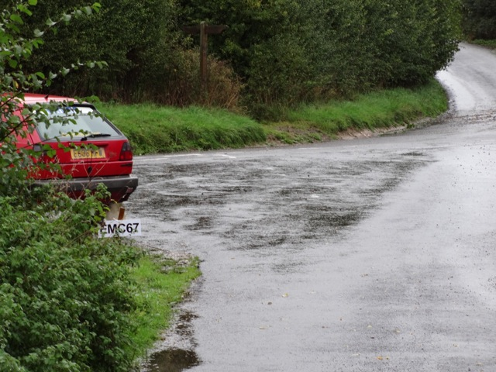
Dodgy code board location

1st Novice and 4th overall was the Dolphin crew of Derek Looker/Stuart Harrison who had a good run round missing one board that may of cost 3rd. Stuart feels that he may have found his stomach’s limit, just starting to feel groggy at 100 miles.

Car 6 Colin Woodhouse and Chris Moore was another crew clean on time with 2 missed boards dropping them down to 5th overall 3rd expert. With Colin using the event as shakedown run for The Great Bustard and Chris concerned he was in the wrong class, both went home happy.

The nippy Suzuki Ingis sport pairing of Jon Hunt /Dan Brentnall finished 2nd Novice 6th overall, losing a bit of time here and there whilst plotting and 3 missed boards. A couple of times Dan forgot he had the navigation for the next section in his hand whilst waiting in controls, costing them the odd minute.

2nd beginner 7th overall were John Considine and late stand in navigator Dom Warner who only dropped 4 minutes in time, but missed a loop picking up 50 penalties for 1 section and then 2 more boards towards the end.

Thanks to the 8 marshals who helped man all the controls, of note was Steve Hayward singlehanded doing 3 controls and coping with 6 cars at once at TC10. Also Shaw Brown and Chris Bullock being dropped in at the deep end and ably covering 2 controls on their first ever rally.

The aim of the event was to get all competitors round the route without going OTL, (which is the result I have managed on my last 2 events driving, both times winning my class with a 3rd and 5th overall from 11 entries). This was achieved with both drivers and navigators enjoying the right balance between workable handouts and flowing roads.

Thanks all for attending

Glynn and Chris
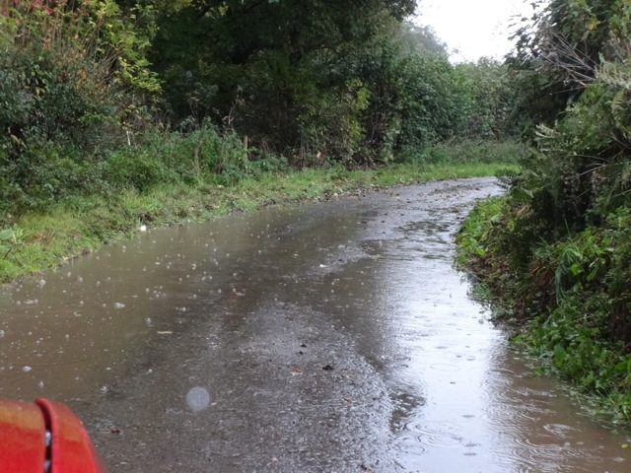
Road where the blockage was when collecting boards

